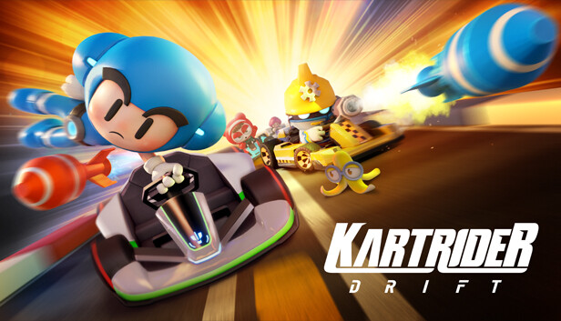

##### **KART RIDER DRIFT**

About This Game:



Kart Rider: Drift is a **fun free-to-play, cross-platform kart racing game where arcade thrills and fast drift-fueled competition meet customized karts and character personalization**. All Reviews: Mostly Positive (2,563) - 75% of the 2,563 user reviews for this game are positive. Release Date: Jan 9, 2023.